MSR 213U Series Programming Documentation for ProClerk to work with USB Interface Card Reader.

- Install software that comes with scanner onto computer you want to program device with. Note: Software does not need to be installed on all computers; it is only used for programming device. Also, if it asks you during the installation of the software to overwrite newer files on your computer choose to keep what is newer on your computer.

Example: Open windows explorer and click on 213CS611.exe in the Setting AP directory to install software.
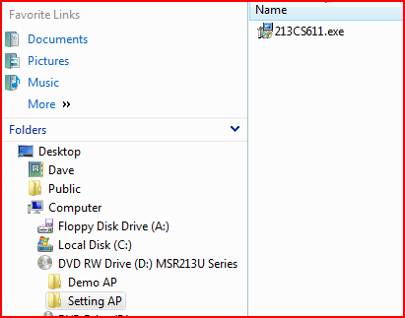

- Plug magnetic strip reader into USB port. A green light should come on indicating reader is connected and recognized.

3. Run setup program 213CS611
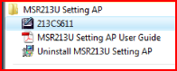

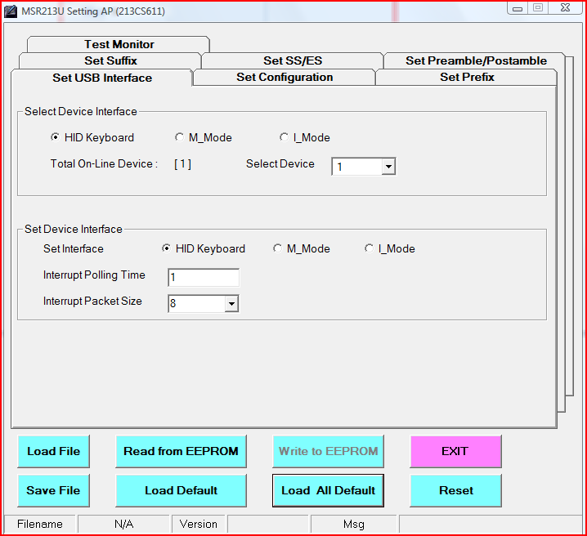

Note: If on the line “Total On-Line Device” you don’t see a [1] try unplugging the magnetic stripe reader and rebooting your computer.

- Click on the “Load File” button and select the MSR213USetup.bin file that you downloaded from the web.

- Click on the “Write to EEPROM” button to run this file which will program your scanner.

- The green light on the magnetic stripe reader should turn off, you should hear a beep, and the green light should turn back on.

- Your magnetic stripe reader is now programmed.

