MSR 210U Series Programming Documentation for ProClerk to work with USB Interface Card Reader.

*********** WARNING **************

You cannot program this device using a computer running the VISTA operating system. We are currently working with support to try and resolve this issue. You will need to find a Windows XP computer to do the programming. Once you have performed a one time programming of this device in XP it will work fine with VISTA.

- Install software that comes with scanner onto computer you want to program device with. Note: Software does not need to be installed on all computers; it is only used for programming device. Also, If it asks you during the installation of the software to overwrite newer files on your computer choose to keep what is newer on your computer.

Example: Open windows explorer and click on setup.exe in the Setup AP directory to install software.
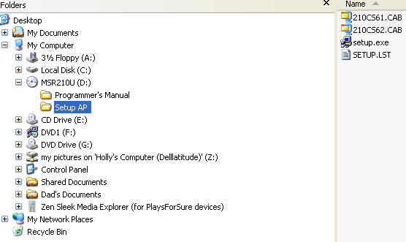

Accept all of the default settings for installing software. If it tells you about a version conflict click yes to keep newer files on your computer.
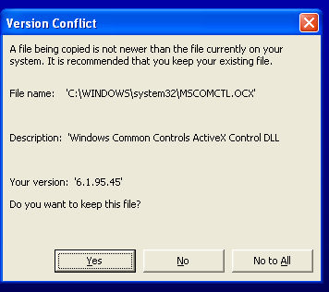

- Plug keyboard into USB port.

3. Run setup program 210CS611

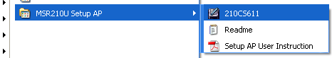

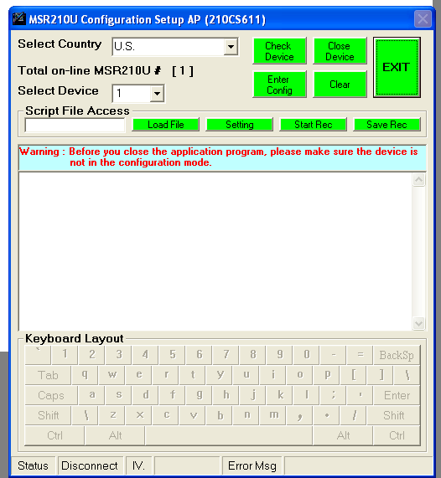

Note: If on the line Total on-line MSR210U # [1] you don’t see a [1] click on the Check Device button to load your device.

- Click on the Load File button and select the MSR210USetup.Text file that you downloaded from the web.

- Click on the Setting button to run this file which will program your scanner.

6. You should see a series of screens go by plus a series of beeps plus the green light on your scanner will be blinking. Once the green light stops blinking and click on the EXIT button and your scanner should be programmed.

